## Lessons 15–17 – Activity Sheet

## Getting Started

## In Lesson 4 we looked at how the line sensor can be used to detect a black line.

## You experimented with thickness and colour of the line to get the best signal

## You will now use this information to enable you to get your car to follow the racing line around the track

## The Bit:Bot official extension has a built in line follower variable

## The extension sensor is digital and will read a 1 with no detection and a 0 for line detected

* Use the line templates or draw your own and the sample code as a starting point to make your car a line following car

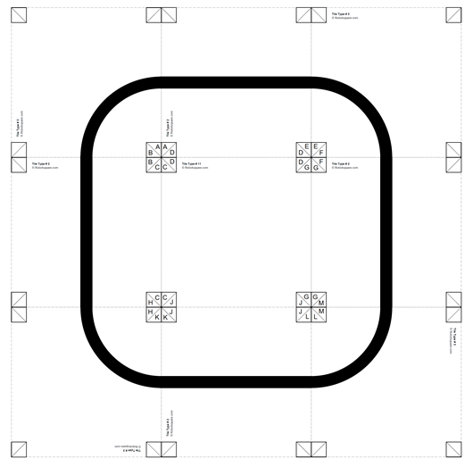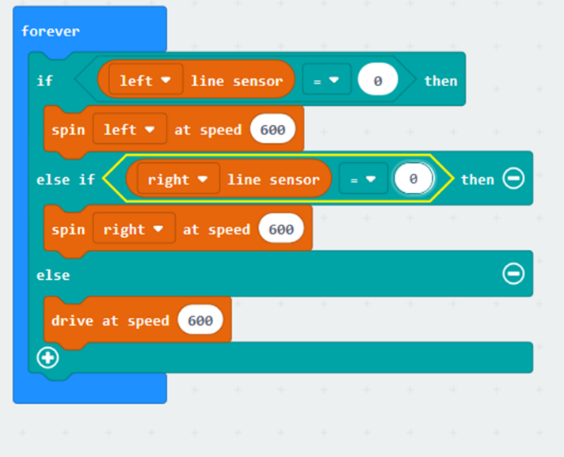

## Success Criteria

* Be able to apply what you have learnt to make the car complete one lap autonomously
* Complete one safe lap as quickly as possible
* Utilise sensors to automate the car and make the vehicle more ‘intelligent’

## Pro-tip

## **Think about**

## Do I want a line to follow all around the track? or do I just want to use the line to stop me hitting an object?

## Test Time

* Does your car follow the line on the test track?
* Add lines as required to the racetrack – can your vehicle get round the track
* What happens with multiple cars and multiple lines?

## Stretch Tasks

* Consider how you could use line followers as collision avoidance – would this solve the problem of multiple cars on the track?
* Experiment with using lines to keep a robot inside a box
* Step it up: have cross overs, wide lines, and racing lines

## Final Thoughts

* In today’s lesson we have looked at how we can use a line follower as a sensor to guide our vehicle around the track, built and tested our tracks and modified the racetrack
* We have discussed the problems with multiple cars on the track and considered how we could mitigate this problem